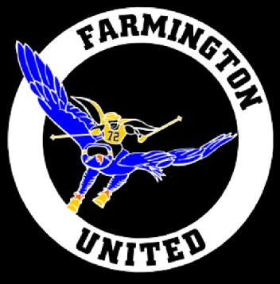

Dear ___________:

The Farmington Alpine Ski Team Booster Club is a 501(c)(3) organization whose purpose is to assist and support the Farmington United Ski Team. The team, consisting of a boys and girls teams at the varsity and junior varsity levels, is comprised of skiers from both Farmington High Schools.

Since the school district only pays our coach’s stipend, we rely upon donations from companies and individuals in our community to help support the teams’ expenses. Our biggest expenses include transportation, league fees, and equipment.

To recognize your support your logo can be displayed on our team banner displayed at race nights, spirit wear worn by our skiers, our website and more. The sponsorship levels are on the back of this letter. If you decide to support our team by sponsoring or donating, please complete and return the attached form.

If you have any questions, we would be glad to speak with you about your participation. Please email farmingtonskiteam@yahoo.com and someone will contact you promptly. We hope you can help support the Farmington United Ski Team.

Sincerely,

Cheryl Fried
Farmington Alpine Ski Team booster club

Sponsorship levels
Coach’s Award  $100-$500 | Banner - Logo or business name advertised on the team banner displayed at each ski meet  Website - Logo or business name advertised on the team website  Banquet - Logo or business name prominently displayed at end-of-year team banquet
Bronze Medal  $500-$999 | Business Name Listed on Spirit wear shirts  PLUS Coach’s Award benefits
Silver Medal  $1000-$2499 | Business Logo and website address or phone number on spirit wear shirts  PLUS Bronze Medal Award benefits
Gold Medal  $2500 + | Individual Sponsor Banner - Logo and business name advertised on individual banner and displayed at each ski meet and local Farmington events (ie: Light Up the Grand Parade)
Any Amount and in-kind donations | We welcome individual donations in any amount. We also welcome donations of products or services. Every year we hold a silent auction fundraiser in which these items can be raffled off. Opportunities to help the team could include apparel, travel-related donations, catering or hospitality items, etc. Please contact us for assistance in creating a custom package to meet the needs of both your business and the team.

Please make the check payable to FAST and mail to:
Cheryl Fried
32562 W. 11 Mile Rd.
Farmington Hills, MI 48336

Company Name:_________________________________________________

Contact Person:__________________________________________________

Contact Phone number:___________________________________________

Thank you so much for your support of the Farmington United Ski Team!

